**Variables, data types, console and arithmetic operations**

1. **What is programming?**

* Computer science
* To communicate with computer commands are used
* Commands are organized one after the other in the other we want them to be executed.
* Sequence of commands is called computer program.

1. **What is a program?**

* Sequence of commands.
* It could consist of arithmetic operations, control flows and repetitions.
* Programs are written in text format.
  + Program code is called source code.
* Source code is compiled to file, which can be understood and executed by the computer.
  + For example Main.cpp is complied to Main.exe.

1. **C++ more info**

* It is used for the development of: video games, operating systems, finance applications and etc.
* It is closer to hardware and thus faster.
* Operating systems like Windows, MacOS and Linux are written in C++.

1. **First console program.**

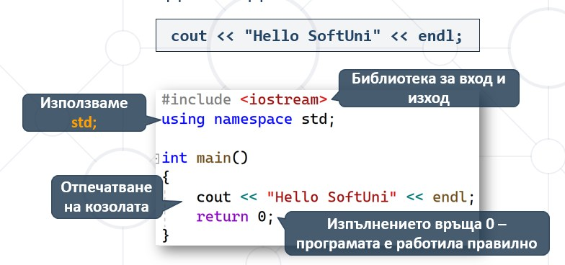

1. **Variables and data types.**

* Computers work with data
  + Data is saved in computer memory in variables.
  + Variables have name, type and value.
* Declaring variables and acquiring value.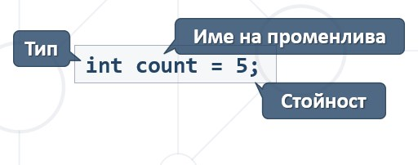
* Data types: int, double, string, char.

1. **Get user input through console.**

* Getting input:

string namе;

cin >> name;

1. **Simple operations**

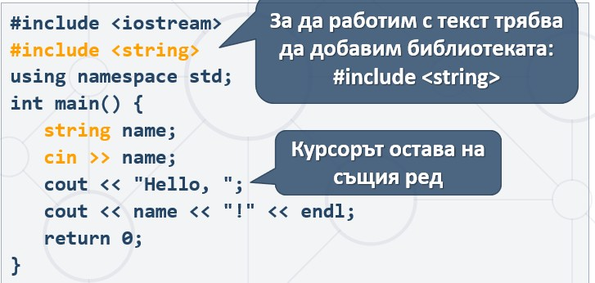

* Multiplication *

int a = 5;

int b = 7;

int product = a * b; //35

* Division

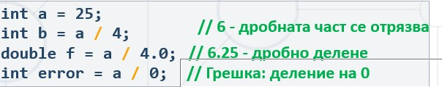

* Modular % - returns the remainder of the division of two int numbers

